Title: | Particle (Grain) Size Analysis by Laser Granulometry (diffraction, diffractometry) with Malvern Mastersizer 3000
From: | Peter Morgan | Date: | 29/11/19

What does the instrument measure?

The Malvern Mastersizer measures the size of particles, these could be anything and these instruments are used in a range of industries from china clay mining, to pharmaceuticals and the food industry making chocolate!
In Geography and Environmental Science, we are typically interested in the particle size distributions of sediments and soils. Often, we wish to quantify the proportions of sand, silt and clay in a sample. Typically, we define these size classes after Wentworth (1922): Sand 63 micron to 2mm, silt 2 to 63 microns, clay less than 63 microns. Sands we can measure physically by sieving through test sieves, but silt and clay require different methods, one of which is laser granulometry.

Note different methods give different results; laser granulometry calculates particle sizes as spherical volume equivalents, sieving physically separates based on the smallest axis. (Blott and Pye 2006; Beuselinck et al 1998).

How does the instrument work?

At first glance the sleek, small instrument seems to be doing a lot for something that looks like a cross between a computer and a coffee machine.
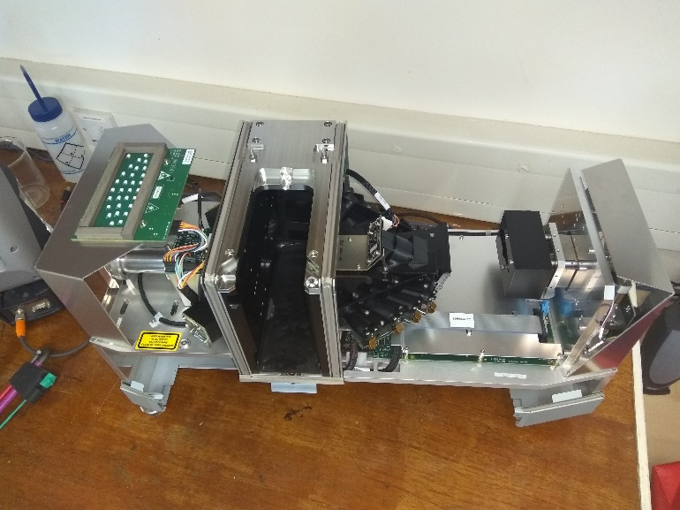
Beneath the cover you can get a sense of what’s going on (also see poster by the instrument). The sample is introduced by wet dispersion in the Hydro EV unit, here its stirred and subject to ultrasound (if you desire).
It then flows continuously through the piping and the flow cell inside the main instrument. The flow cell is the vital optics and must be kept clean, contact a technician if you think it needs cleaning don’t do it yourself. In the flow cell the sample is subject to the instrument’s laser beams (red and blue). The light from these lasers is scattered (but contained by the instrument housing) by particles in the sample and detected by the array of detectors.

The instrument then computes the particle size distribution of the sample based on the light scattering pattern it has detected. Simple!

The particle size reported is a spherical equivalent diameter, so for example a rectangular box shaped particle could have the same volume as a sphere of 226 microns in diameter so that would be the reported particle size.

What data is generated?
This is customisable, but typically it’s a volume percentage in the different size classes detected, see below some particle size distributions of test samples of different sediments/soils.

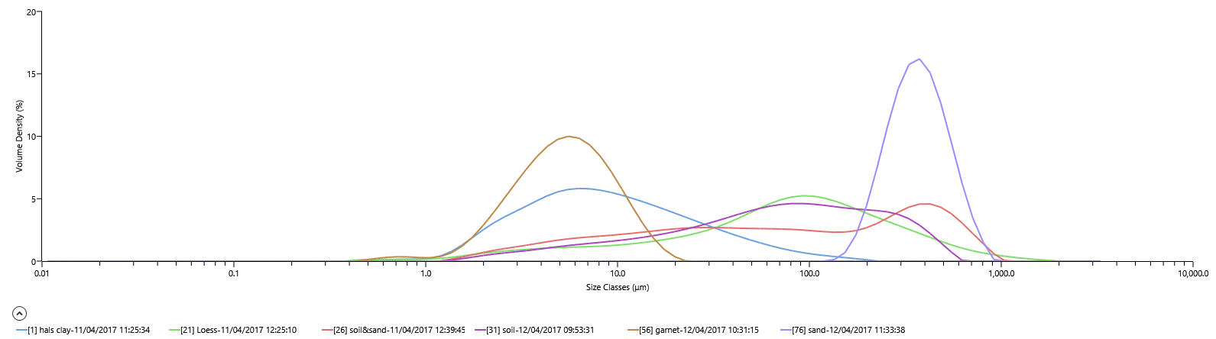

You can customise reports but the “sediments” one I have created will show sample information, statistics, raw data and a sediment classification based on the Wentworth classes (eg sandy loam etc). this you can export to excel using the export feature. Or from any report copy and paste data or images to make your own data table/report in software of your choice.

 | Average of 'LIN L6 10-11cm'
Fraction | % in
Clay (<2um) | 0.6
Silt (2 - 63um) | 65.57
Very fine sand (63-125um) | 22.78
Fine sand (125-250um) | 10
Medium sand (250-500um) | 1.04
Coarse sand (500-1000um) | 0
Very coarse sand (1000-2000um) | 0
Total sand (63-2000um) | 33.83

Sample Preparation
Sample preparation is critical, you need to ensure the sample you present to the laser in the instrument is representative of your whole sample and that that is representative of your sampling area. For example from a whole field you may end up analysing less than a gram of sediment.

Some guidelines on how much sample you will need:
- 90g for 3000 microns
- 25g for 2000 microns
- 5g for 1000 microns
So using this system for sediments as described below you’ll want c.5 grams of sample.
The typical preparation is:
- Split the field sample using a rifler.
- Sieve to at least 2mm but preferably 1mm using Endecotts test sieves.
- Mix with a spatula to form a homogenous 'paste' with a weak dispersant solution of 5% Sodium hexametaphosphate (calgon).
- Subsample the paste using multiple stabs of a small spatula all over the paste onto a plastic watchglass.
- Physical disaggregation carried out with a rubber pestle.
- The sample is then washed with distilled water from the watchglass into the Hydro EV unit of the Malvern Mastersizer 3000 analyser.

For organic sediments you may wish to pre treat samples to remove organic matter, typically this is done with Hydrogen Peroxide (Allen and Thornley 2004) (Used a fume cabinet in the Chemical Preparation Laboratory).

Instrument set up
After turning on give the instrument 15-30 minutes to warm up and internal temperatures to stabilise before beginning analysis.
Typically, when analysing sediments particles are non-spherical. Because all materials have different refractive properties it is important to tell the instrument what material is being tested. Malvern have provided an approximation of the refractive properties of a generic soil. Our dispersant is deionised water, it is best to take this from the Elga machine as near to analysis as possible.
Sampling duration should be 10-20 seconds. Measure the background for the same amount of time as sampling.
Each test should comprise 5 measurement, it’s advantageous to include a pre measurement delay (eg 20 seconds) to ensure dispersion in the system, and a short delay between measurements (eg 5 seconds).
Obscuration is roughly equivalent to sample concentration in the measurement cell, it’s a measure of how much laser power is blocked or obscured by the sample particles. For coarser particles a higher obscuration is needed to get representative, repeatable sampling. For finer particles a much lower obscuration is sufficient. Samples with wide ranging particle size distributions can be a challenge to get good representation across the range. Too much sample will cause multiple scattering and artificially increase the reported fine fraction, too little sample will underrepresent the coarse fraction. For sediments obscuration of 10-20% is typical. Try starting at around 15% to develop your methodology for an unknown sample.

Check Background Cleanliness by specifying an alarm condition of maximum energy level on detector 1 of 100, and 20 on detector 20. A clean background should be a smooth curve decreasing from the highest energy at detector 1. Any bumps in this indicate contaminated dispersant 9run a cleaning cycle) or dirty optics (contact a technician to clean the measurement cell). Note a clean background is critical for data quality.

A stirrer speed of 2500 rpm, standard 3 cycle clean and general purpose analysis model should be suitable for most samples.

When analysis samples observe the relative standard deviation (RSD) of the D10, D50 and D90 values over 5 measurements. These approximate the coefficient of variance (COV) (ISO 1332-1 Section 6.4). These should be 5% for D10 and D90 and 3% for D50. If they are not adjust settings and re-test.

A workable order of priority for this is:

- Re-measure (dispersion may be better given the greater time circulating in the system)
- Add more sample to increase obscuration, this will help reproducibility particularly of D90.
- Increase stirrer speed to increase dispersion. (this can mobilise larger particles)
- Initiate ultrasound in fixed bursts to increase dispersion (this can break up aggregates)
- Clean system and prepare another sample (sometime you just have to start over!

Looking on the trend graph will show you the vales and obscuration (note the scale will change so you may not be seeing large changes). Increasing obstruction means the sample is dispersing, perhaps aggradations are breaking down. Decreasing obscuration could mean the opposite so add more energy to encourage dispersion.

References

Allen, J, R, L. and Thornley, D, M. (2004). Laser Granulometry of estuarine silts: effects of Hydrogen peroxide Treatment. The Holocene. 14. 290

Beuselinck, L, Govers, G, Poesen, J, Degraer, G, Froyen, L. (1998). Grain size analysis by grain diffractometry: comparison with the sieve- pipette method. Catena. 32. 193-208

Blott, S, and Pye, K. (2006) Particle size distribution analysis of sand sized particles by diffraction. Sedimentology. 53. 671-685

ISO 1332-1 Section 6.4 (2009) Particle Size analysis-Laser diffraction Methods. International Standard
Wentworth, C, K. (1922) A scale of grade and class terms for clastic sediments.

